Support for Children
We are an inclusive school that welcomes and celebrates diversity. All staff believe having high self-esteem is crucial to a child’s emotional well-being and academic progress. We have a caring, understanding team who look after all of our children.

1. How does the school know if my child needs extra help?
We have a number of methods to help us identify if a child needs extra help. These include:
- Information from your child’s pre-school or previous school.
- Home visits or 1;1 meetings by class teachers in Reception
- Class teacher/ TA visits to feeder pre-school to observe your child and speak to their key worker.
- Speaking to parents/ carers and previous teachers.
- Spending time with your child and getting to know them.
- Listening to your child’s voice.
- Information from other services who have worked with your child, for example a speech and language therapist.
This information will be used to ensure that we meet any additional needs your child may have. Once your child is in school we will monitor their progress and development. If we have concerns we may ask other professionals to give advice and support.
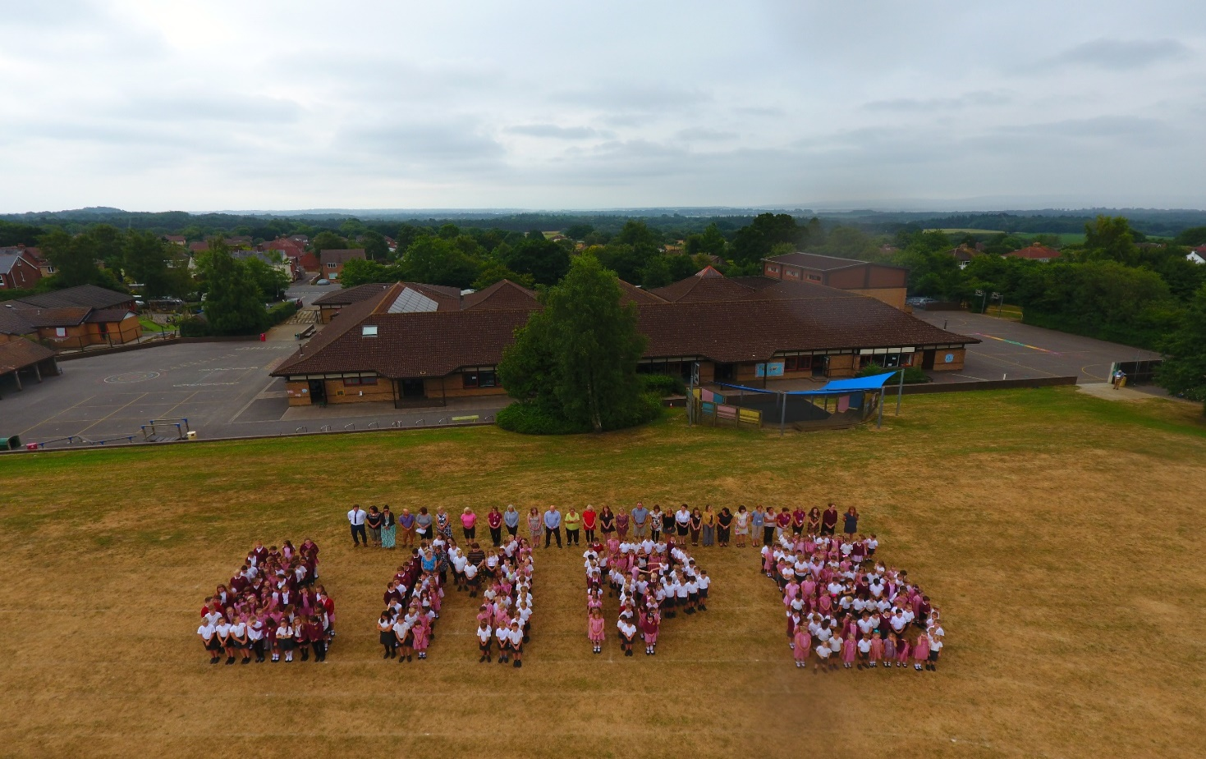
What are the different types of support that may be available for children at Lytchett Matravers Primary School.
Area of need | Whole school, universal provision | Possible focused support for children’s additional needs
Cognition and Learning (moderate/ specific learning difficulties.) | - Differentiation of the curriculum and teaching.  - Teaching resources are assessable and appropriate.  - Interactive and inclusive learning environment.  - Multisensory approach to learning. | - Individual education plan.  - 1:1 intervention – reading, maths, writing.  - Differentiated resources.  - Alternative methods of recording.  - Additional in class TA support.  - Individual pupil observations.  - Support through the local authority – specialist teachers.  - Further assessments carried out to identify specific areas of need.
Communication and interaction. | - Strong emphasis on speaking and listening.  - Creation of a vocabulary rich environment.  - Strong phonics teaching in EYFS and Key Stage 1 | - Small group phonics support.  - Pre- teaching of vocabulary  - Alternative communication strategies used; signalong, PECS.  - Speech and Language Therapy (SALT) sessions – online and/or face to face.  - Regular opportunities throughout each week to practise SALT targets with 1:1 TA support.  - Assess to technology to support communication, such as IPads and laptops.
Social, emotional and mental health difficulties. | - Consistent use of the school’s relationships and behaviour policy.  - A positive, supportive and nurturing whole school environment.  - Delivery of the SCARF PHSCE curriculum.  - Circle time.  - Assemblies/ Collective Worship. | - Targeted intervention to promote social skills and emotional resilience.  - Intervention delivered by our ELSAs (Emotional, literacy, Support Assistants.)  - Class observations and playground observations by Pastoral Care worker and SENDCo.  - Personalised Behaviour Management Plans (BMP) and Behaviour Handling Plans.  - Additional advice and support from outside agencies – eg CAMHS, Paediatricians, Outreach, Early Help.
Sensory and/or physical needs, e.g. hearing and visual needs. | - Seating position in class prioritised.  - Provision of specialist equipment.  - Curriculum adapted – e.g. enlarged texts.  - Use of ear defenders. | - Additional modifications to the school environment.  - Liaison with a range of medical professionals.  - Regular visits from Hearing Support and Vision Support services through Dorset Council, providing advice, support and next steps for the child.  - Learning support timetabled throughout each week.  - Learn to Move, Move to Learn, small group/ 1:1 intervention.
Autistic Spectrum Disorder (ASD). | - Multi-sensory approach to learning.  - Structured and consistent timetabling.  - Visual prompts used to aid learning, such as visual timetables.  - Positive behaviour management.  - Learning Styles understood.  - Transition support timetabled in to the day. | - Small group/ 1:1 intervention.  - ICT used to remove barriers to learning.  - Social stories/ social strips used to prepare and manage transitions.  - Outreach support through local special schools.  - Movement/ brain breaks timetabled.  - Social & emotional aspects of learning explored with the ELSA team as required.  - Personalised, teacher led support and planning.

What should I do if I think my child may have special educational needs?
In the first instance talk to your child’s class teacher. Your concerns will always be taken seriously, as your views are very important to us.
The class teachers are responsible for planning the curriculum and differentiating to meet the needs of all the pupils within their class, assessing your child’s progress and highlighting initial concerns regarding your child’s holistic development.

2. How will school staff support my child?
- Your child’s needs will be met within the class, supported by high quality planning and teaching that takes account of the needs of each child.
- The progress of all children is reviewed on a regular basis.
- The school uses a graduated response to SEND and intervention.
- Where necessary an individual programme of support will be used and progress monitored. These are known as Individual Education Plans (IEPs)
- The class teacher will develop an IEP for your child alongside the Inclusion Leader, setting appropriate targets. These will be reviewed three times a year to ensure that support remains appropriate.
- Additional support/ interventions are time limited and rooted in a Cycle of Assess Plan Do Review, in line with the SEND Code of Practice.
- Where necessary the school may seek support from outside services. This will be discussed with through a co-production meeting and a referral made with your permission.
- The Business Manager, Headteacher and Governing Body are responsible for monitoring how effectively funding is used to support the teaching and learning of pupils with SEND. There is a designated SEND Governor who works closely with the SENDCo/ Inclusion Leader.

3. How will the curriculum be matched to my child’s needs?
- Lessons are pitched appropriately so that all children can learn and progress.
- Teachers take account of the needs of the individual child and plan different tasks and materials appropriately.
- Tracking and assessment enables each class teacher to analyse the progress of the child. Personalised intervention is implemented if appropriate.
- Reviews of learning targets for your child are reviewed three times a year with the class teacher and new programmes or support is organised as necessary, leading to personalised learning.
- Targets are set to support children’s individual needs and to ‘close the gap’ which are regularly updated.
- Children work in a variety of groupings, such as small supported groups, 1:1, mixed ability and similar ability groups.

4. How will both you and I know how my child is doing...

...and how will you help me to support my child’s learning?

We want to work co-productively with all parents.
- You will be able to discuss your child’s progress at Parents’ Evenings.
- We will work with you and your child to create achievable targets for your child so that all involved are working as a team. These targets will be recorded as part of your child’s Individual Education Plan (IEP).
- Your child’s class teacher will be available via email or through the school office if you wish to raise a concern. Appointments can be made to speak in more detail to the class teacher or SENDCo/ Inclusion Leader by visiting the school office.
- The class teacher may suggest ways of how you can support your child.
- The Inclusion Leader may meet with you to discuss how to support your child with strategies to use if there are difficulties with a child’s behaviour/emotional needs.
- If appropriate Behaviour Response Plans and/ or Behaviour Management Handling plans will be written in co-production with you.
- If outside agencies or the Educational Psychologist have been involved suggestions and programmes of study are normally provided that can be used both at home and in school.
- If your child has complex Special Educational Needs they may have an Education, Health and Care Plan (EHCP). These will contain detailed targets and a summary of your child’s strengths and needs. We invite parents/carers, external professionals and appropriate school staff to attend at least one formal meeting a year. These are known as Progress Reviews or Transition Reviews if your child is in Y6. These meetings look at reviewing and setting appropriate targets and actions and ensuring the current provision is appropriate to meet your child’s needs.

5. What support will there be for my child’s overall well-being?
Support we can provide in school may include:
- Nurture Groups
- Social skills and friendship groups
- ELSA support
- Pastoral mentoring/ family support
- Behaviour programmes including rewards and sanctions.
Medical
- Medicines can be administered in school with signed parental permission.
- There are nominated first aiders in school and several members of staff have paediatric first aid qualifications.
- If your child has significant medical needs you will need to speak to the Inclusion Leader to discuss how we can best support you and your child. This might include drawing up a Health Care Plan.
- If a Medical Care plan is required Mrs McGrail – Pastoral Lead, will support you with completing this.
The class teacher has responsibility for the overall well-being of every child in their class. If you have any worries please speak to your child’s class teacher first. If further support is needed the class-teacher will speak to the Inclusion Leader.

6. What specialist services and expertise are available at or accessed by the school?
Currently we have teachers and teaching assistants who have had training in the following areas:
- Speech and Language
- Dyslexia
- Autistic Spectrum Disorder
- Emotional Literacy (ELSA)
- Bereavement
- Anxiety
- Attachment and resilience.
- Emotion Coaching
- Trauma Informed Practice - PACE
We may access support from other services, for example;
- Educational Psychology Service
- Speech and Language Therapy
- School Nurse
- Early Years Services
- Education Support, Behaviour and Attendance Service
- Occupational Therapy
- Child and Adolescent Mental Health Service (CAMHS)
- Counselling services
- Service for Children with Sensory Needs
- Children’s Services
- Purbeck Locality Team – Specialist Teachers
- Behaviour Lead – Hamwic Education Trust
- Attention Deficit Hyperactivity Disorder (ADHD)
- Sensory needs
- Motor skills
- ELSA
Some of the learning interventions which we deliver include;
- 1st Class@Number
- 1st Class@Number 2
- Success@arithmetic
- Dandelion Reading Comprehension.
- Read, Write, Inc
- Learn to Move, Move to Learn.
- NELI

7. What training have staff had, or are undertaking, to support children with special needs?
- The Head Teacher is the Continuing Professional Development (CPD) Lead for class teachers, and the Inclusion Leader is the CPD for teaching assistants. Both roles ensure that all staff have the skills they require to support pupils.
- The Deputy Head teacher is the Lead Teacher for Looked After Children (LAC) and supported by the Inclusion Leader. Both staff members have received additional training in order to fulfil this role.
- Skills audits are carried out and a rolling programme of training is delivered by staff in school or outside services.
- Group and individual training has included: Read Write Inc, Bereavement and Loss, Emotional Literacy, Speech and Language support, Challenging Behaviour/ADHD Learn to Move/Move to Learn, Early Birds Autism, Attachment and dyslexia.
- Shadowing/peer observation regularly takes place.
- Medical training to support pupils with medical care plans such as epilepsy, diabetes and epi-pen training.

8. How will my child be included in activities outside the classroom, including school trips?
- We make sure that activities outside the classroom and school trips are available to all.
- Risk assessments are carried out for each trip and a suitable number of adults are made available to accompany the pupils, with 1:1 support if necessary.
- Parents/carers may be invited to accompany their child on a school trip if this ensures access.
- After school clubs are available to all pupils. Vulnerable pupils are given priority and adjustments will be made to support their participation.
- Health and safety audits will be conducted as and when appropriate.
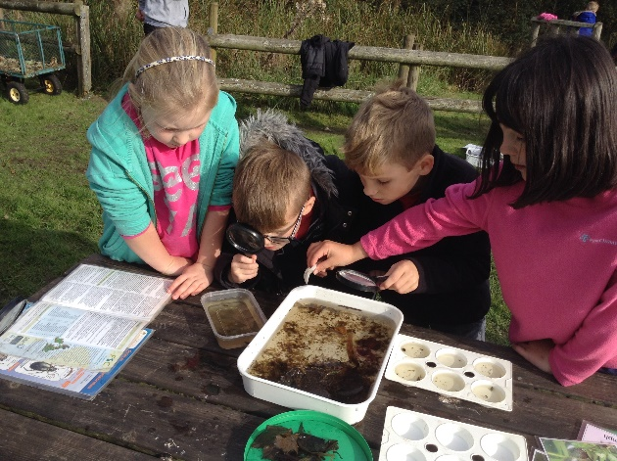
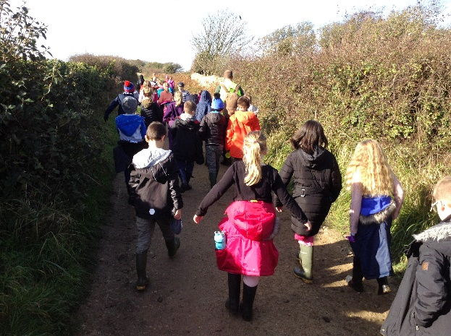

9. How accessible is the school environment?
- The school site is wheelchair accessible
- We have a disabled toilet that is large enough to accommodate changing and suitable for wheelchair users.
- There is a designated disabled parking bay outside the front of the school.
- Visual timetables are used in all classrooms.
- We have an accessibility plan, which is available to view on our school website.

10. How will the school prepare and support my child to join the school, transfer to a new school...

... or the next stage of education and life?
- Induction events take place during the summer term for all children who are joining the Foundation Stage in September.
- Close liaison between Inclusion Leader and all teachers, especially those teachers in Early Years, Year 2 and Year 6. This may involve multi-agency meetings to support the transition
- Good transfer of all SEN information.
- Previous schools contacted for information sharing.
- Staggered entry to Early Years Foundation Stage classes.
- Meet the teacher meetings are held at the beginning of the Autumn term for parents/carers to meet their child’s new teacher and find out about the new curriculum.
- Transition to new class is facilitated by sessions during the summer term with new class teachers and environment.
- Transition sessions for Year 6 pupils during the summer term or earlier if necessary.
- New school are invited to attend any reviews prior to transition.
- Pupil voice (children are asked their views on an issue either individually or in small groups.)

11. How are the school’s resources allocated and matched to children’s special educational needs?
- The special educational needs (SEN) budget is managed by the Head Teacher, School Business Manager, Inclusion Leader and SEN Governor.
- Resources are requested and ordered as necessary to support each pupil’s learning.
- Regular meetings are held to monitor impact of extra support.
- The governing body is kept informed of funding decisions.

12. How is the decision made about what type and how much support my child will receive?
- We use the Hamwic Education Trust Graduated Response model.
- Each child is assessed individually according to the SEND Code of Practice and LA guidance, and personalised or group learning support programme(s) will be developed dependent on need.
- Additional assessments from outside services, such as Educational Psychologists, Specialist Teachers and Speech and Language will inform the types of support and/or resources needed.
- Regular review meetings with appropriate staff are carried out to discuss your child’s progress and any additional needs that require support.
- School based plans are discussed with parents and staff up to three times a year (if appropriate).
- Children who have an Educational, Health and Care Plan (EHCP) will also have an Annual Progress Review to review the desired outcomes listed on their EHC Plan.

13. How are parents involved in the school? How can I be involved?
- All parents are actively encouraged to take part in the school community. This may include, but is not limited to:
- Assemblies
- Leading workshops and sharing skills
- Hearing children read
- School visits
- Being part of PTEC (Parents, Teacher Event Committee)
- Delivering and supporting extra-curricular activites.

If you are able to offer some time to support the children within the school please do contact the school office.

14. Who can I contact for further information?
In the first instance if you have a question, query or comment please speak to your child’s Class teacher. Contact can be made in person or through the school office.
Other useful contacts as of September 2021 are;
- Inclusion Leader – Mrs Heather Helm
- Head Teacher – Mr Simon France
- Deputy Headteacher and Lead Teacher for Looked After Children (LAC) – Laura Dominey.
- Governor for SEND - Rachel Thynne
- School website – www.lmpsdorset.org
If you have a question, want to look around or perhaps you feel that your child’s needs are hard to meet and you want to discuss the matter in more depth, do not hesitate to contact us.

15. Who can I contact if I want to make a complaint?
It is hoped that most concerns can be expressed and resolved on an informal basis. However, if you do have any grievance or complaint then please follow the link on the Hamwic Education Trust website at https://www.hamwic.org/policies. Printed copies can be requested through the school office.
If your child has an Education, Health, Care Plan issued by Dorset Council and you wish to make a complaint please contact Emma Adlem – Provision Lead emma.adlem@dorsetcouncil.gov.uk
If your child has an Education, Health, Care Plan issued by BCP and you wish to make a complaint please contact sendbso@bcpcouncil.gov.uk

Useful Links
Dorset SEND Local offer - Dorset's Local Offer - Dorset Council
BCP Local Offer - The Bournemouth, Christchurch and Poole SEND Local Offer - BCP Council | BCP FID (bcpfamilyinformationdirectory.com)
NASEN - https://nasen.org.uk
Hamwic Education Trust - Home - Hamwic Education Trust

